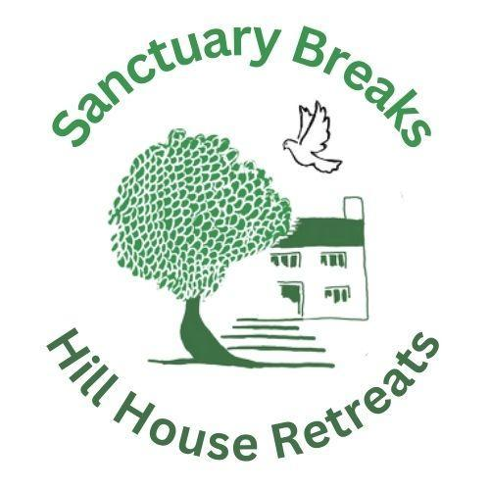

Sanctuary Breaks CIO at Hill House

Background Information

Sanctuary Breaks (RC 1204540) was registered as a charity in August 2023.
Our Vision is that: People seeking sanctuary - especially those seeking asylum, refugees and survivors of trafficking or torture - find, at Hill House, respite from the emotional traumas they have experienced and grow in confidence and self-esteem in a community that understands and accepts them.

We do this by: enhancing the mental health and wellbeing of people seeking sanctuary, by providing a place of welcome, safety, rest and hope, for short breaks, day visits, and a range of activities at Hill House; by providing opportunities for contact, inclusion and engagement with surrounding communities, thus also raising awareness, understanding and acceptance of refugees for all backgrounds in the wider community; and by increasing confidence and self-esteem amongst the otherwise largely excluded community of people seeking sanctuary by enabling people to develop and demonstrate their skills.
We have a Community Interest Company, Hill House Retreats,which acts as a trading arm for the charity and manages lettings of the property by a range of sympathetic groups for running small retreats and workshops when it is not in use for hosting refugees and also letting through AirBnB. We aim to grow this income over time to cover the costs of our charitable activities.

Sanctuary Breaks has been very successful in this work, partly as a result of having free access to a lovely house and a large garden within the village of Amberley, in a secluded and delightful location. HILL HOUSE has been made fit for purpose specifically in relation to hosting forced migrants, in order to provide a sense of safety, welcome and ‘home’. As far as we know, there is no other house in the country, in a rural area, similarly dedicated to the support and well-being of refugees and people seeking sanctuary, providing short respite day-time or residential breaks.

HILL HOUSE is presently owned by the founder of the CIC and CIO. The charity has recently been offered the gift of ownership of the house in order to continue to develop its work with the key resource under its management. The charity is excited at this prospect and is developing a plan to accept it and develop a long-term sustainable plan to significantly ramp up our charitable work.

From our experience over the past ten years, there is enormous potential to expand our offer. Feedback from refugee guests and visitors, and their host organisations in the refugee support sector, is absolutely positive. All our guests have experienced severe trauma. Feedback underlines the value of even a few hours spent in a homely, beautiful, safe, natural and welcoming environment for people seeking sanctuary as they go through the asylum process. The visits provide a safe place to return to in the mind, which is psychologically essential to cope with PTSD. For many it is the only such place they have in their anxious, open-ended, period of waiting while their claim is decided.

For more information, see https://sanctuaryhillhouse.co.uk

January 2026

